

<<Project name>>
Software Requirement Document
Report 3 - User Requirements

– HoChiMinh, August 2022 –
Table of Contents
Record of Changes 3
III. User Requirements 4
1. Actors 4
2. Use Cases 4
2.1 Diagram 4
2.2 Descriptions 5
3. Business Rules 8

Record of Changes
Date | A*  M, D | In charge | Change Description
*A - Added M - Modified D - Deleted

III. User Requirements

1. Actors
[An actor is a person (or sometimes another software system or a hardware device) that interacts with the system to perform a use case. Following are some questions you might ask to help user representatives identify actors
- Who (or what) is notified when something occurs within the system?
- Who (or what) provides information or services to the system?
- Who (or what) helps the system respond to and complete a task?
This part gives the description of system actors, you can follow the table form as below]
<<Sample:
# | Actor | Description
1 | Patron (favored) | A Patron is a Process Impact employee who wants to order meals to be delivered from the company cafeteria. There are about 600 potential Patrons, of which 300 are expected to use the COS an average of 5 times per week each. Patrons will sometimes order multiple meals for group events or guests. An estimated 60 percent of orders will be placed using the corporate Intranet, with 40 percent of orders being placed from home or by smartphone or tablet apps.
2 | Cafeteria Staff | The Process Impact cafeteria employs about 20 Cafeteria Staff, who will receive orders from the COS, prepare meals, package them for delivery, and request delivery. Most of the Cafeteria Staff will need training in the use of the hardware and software for the COS.
3 | Menu Manager | The Menu Manager is a cafeteria employee who establishes and maintains daily menus of the food items available from the cafeteria. Some menu items may not be available for delivery. The Menu Manager will also define the cafeteria’s daily specials. The Menu Manager will need to edit existing menus periodically.
4 | Meal Deliverer | As the Cafeteria Staff prepare orders for delivery, they will issue delivery requests to a Meal Deliverer's smartphone. The Meal Deliverer will pick up the food and deliver it to the Patron. A Meal Deliverer’s other interactions with the COS will be to confirm that a meal was (or was not) delivered.
5 | …
>>

2. Use Cases
[A use case (UC) describes a sequence of interactions between a system and an external actor that results in the actor being able to achieve some outcome of value. The names of use cases are always written in the form of a verb followed by an object. Select strong, descriptive names to make it evident from the name that the use case will deliver something valuable for some user]

2.1 Diagram
[Provide the UC diagram(s) to show the actor-UCs and UC-UC relationships like the sample below. You can have multiple UC diagrams for the system]
<<Sample:
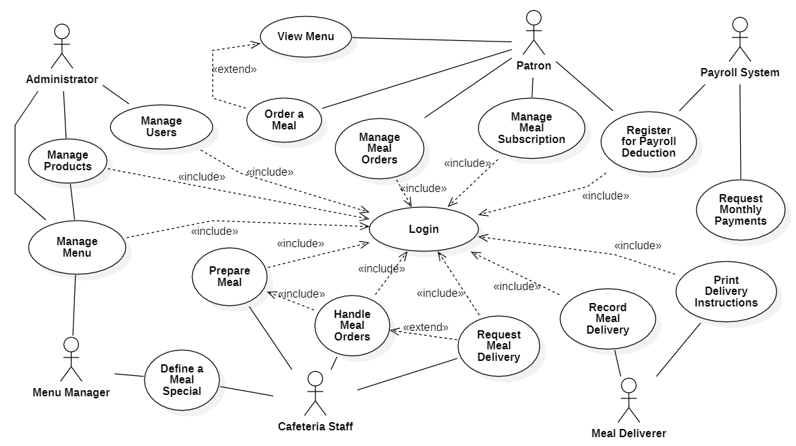
>>

2.2 Descriptions
[This part describes the use cases, you can follow the table form as below]
<<Sample:
ID | Use Case | Actors | Use Case Description
UC-01 | Order a Meal | Patron  Cafeteria Inventory System | <<Use Case Brief description>>
UC-02 | Register for Payroll Deduction | Patron  Payroll System
…

ID and Name: | UC-01 Order a Meal
Created By: | Prithvi Raj | Date Created: | 10/4/13
Primary Actor: | Patron | Secondary Actors: | Cafeteria Inventory System
Description: | A Patron accesses the Cafeteria Ordering System from the corporate intranet or from home, views the menu for a specific date if desired, selects food items, and places an order for a meal to be delivered to a specified location within a specified 15-minute time window.
Trigger: | A Patron indicates that he wants to order a meal
Preconditions: | PRE-1. Patron is logged into COS.  PRE-2. Patron is registered for meal payments by payroll deduction.
Postconditions: | POST-1. Meal order is stored in COS with a status of “Accepted”.  POST-2. Inventory of available food items is updated to reflect items in this order.  POST-3. Remaining delivery capacity for the requested time window is updated.
Normal Flow: | 1.0 Order a Single Meal  - Patron asks to view menu for a specific date. (see 1.0.E1, 1.0.E2)  - COS displays menu of available food items and the daily special.  - Patron selects one or more food items from menu. (see 1.1)  - Patron indicates that meal order is complete. (see 1.2)  - COS displays ordered menu items, individual prices, and total price, including taxes and delivery charge.  - Patron either confirms meal order (continue normal flow) or requests to modify meal order (return to step 2).  - COS displays available delivery times for the delivery date.  - Patron selects a delivery time and specifies the delivery location.  - Patron specifies payment method.  - COS confirms acceptance of the order.  - COS sends Patron an email message confirming order details, price, and delivery instructions.  - COS stores order, sends food item information to Cafeteria Inventory System, and updates available delivery times.
Alternative Flows: | 1.1 Order multiple identical meals  - Patron requests a specified number of identical meals. (see 1.1.E1)  - Return to step 4 of normal flow.  1.2 Order multiple meals  - Patron asks to order another meal.  - Return to step 1 of normal flow.
Exceptions: | 1.0.E1 Requested date is today and current time is after today’s order cutoff time  1. COS informs Patron that it’s too late to place an order for today.  2a. If Patron cancels the meal ordering process, then COS terminates use case.  2b. Else if Patron requests another date, then COS restarts use case.  1.0.E2 No delivery times left  1. COS informs Patron that no delivery times are available for the meal date.  2a. If Patron cancels the meal ordering process, then COS terminates use case.  2b. Else if Patron requests to pick the order up at the cafeteria, then continue with normal flow, but skip steps 7 and 8.  1.1.E1 Insufficient inventory to fulfill multiple meal order  1. COS informs Patron of the maximum number of identical meals he can order, based on current available inventory.  2a. If Patron modifies number of meals ordered, then Return to step 4 of normal flow.  2b. Else if Patron cancels the meal ordering process, then COS terminates use case.
Priority: | High
Frequency of Use: | Approximately 300 users, average of one usage per day. Peak usage load for this use case is between 9:00 A.M. and 10:00 A.M. local time.
Business Rules: | BR-1, BR-2, BR-3, BR-4, BR-11, BR-12, BR-33
Other Information: | - Patron shall be able to cancel the meal ordering process at any time prior to confirming it.  - Patron shall be able to view all meals he ordered within the previous six months and repeat one of those meals as the new order, provided that all food items are available on the menu for the requested delivery date. (Priority = M)  - The default date is the current date if the Patron is using the system before today’s order cutoff time. Otherwise, the default date is the next day that the cafeteria is open.
Assumptions: | Assume that 15 percent of Patrons will order the daily special (source: previous 6 months of cafeteria data).

ID and Name: | UC-02 Register for Payroll Deduction
Created By: | Nancy Anderson | Date Created: | 9/15/13
Primary Actor: | Patron | Secondary Actors: | Payroll System
Description: | Cafeteria patrons who use the COS and have meals delivered must be registered for payroll deduction. For noncash purchases made through the COS, the cafeteria will issue a payment request to the Payroll System, which will deduct the meal costs from the next scheduled employee payday direct deposit.
Trigger: | Patron requests to register for payroll deduction, or Patron says yes when COS asks if he wants to register
Preconditions: | PRE-1. Patron is logged into COS.
Postconditions: | POST-2. Patron is registered for payroll deduction.
Normal Flow: | 5.0 Register for Payroll Deduction  - COS asks Payroll System if Patron is eligible to register for payroll deduction.  - Payroll System confirms that Patron is eligible to register for payroll deduction.  - COS asks Patron to confirm his desire to register for payroll deduction.  - If so, COS asks Payroll System to establish payroll deduction for Patron.  - Payroll System confirms that payroll deduction is established.  - COS informs Patron that payroll deduction is established.
Alternative Flows: | None
Exceptions: | 5.0.E1 Patron is not eligible for payroll deduction  5.0.E2 Patron is already enrolled for payroll deduction
Priority: | High
Business Rules: | BR-86 and BR-88 govern an employee’s eligibility to enroll for payroll deduction.
Other Information: | Expect high frequency of executing this use case within first 2 weeks after system is released.
>>

3. Business Rules
[Provide common business rules that you must follow. The information can be provided in the table format as the sample below]
<<Sample:
ID | Rule Definition
BR-01 | Delivery time windows are 15 minutes, beginning on each quarter hour.
BR-02 | Deliveries must be completed between 10:00 A.M. and 2:00 P.M. local time, inclusive.
BR-03 | All meals in a single order must be delivered to the same location.
BR-04 | All meals in a single order must be paid for by using the same payment method.
BR-11 | If an order is to be delivered, the patron must pay by payroll deduction.
BR-12 | Order price is calculated as the sum of each food item price times the quantity of that food item ordered, plus applicable sales tax, plus a delivery charge if a meal is delivered outside the free delivery zone.
BR-24 | Only cafeteria employees who are designated as Menu Managers by the Cafeteria Manager can create, modify, or delete cafeteria menus.
BR-33 | Network transmissions that involve financial information or personally identifiable information require 256-bit encryption.
BR-86 | Only regular employees can register for payroll deduction for any company purchase.
BR-88 | An employee can register for payroll deduction payment of cafeteria meals if no more than 40 percent of his gross pay is currently being deducted for other reasons.
>>

